# G:\LOGOS\ISGA\Logo-PNG-01.png



**Higher Institute of Engineering and Business**

**ISGA Rabat**

**Engineering Stream**

**L3 MIAGE**







**Academic year 2017-2018**

# Abstract :

The work presented is part of a project.

Our project is to develop an auction site that allows and encourages people to make sales to online auctions with ease.

# Résumé :

Le travail présenté fait partie d'un projet.

  Notre projet est de développer un site d'enchères qui permet et encourage les gens à faire des ventes aux enchères en ligne avec simplicité.

# Acknowledgements

The project was not a piece of cake for us but rather a challenge we were determined to take. As a group we tackled the task but we couldn’t reach this outcome without the help of our mentors who have been always a great back up for us. Many thanks to M.kamel Ismaili , having someone with your knowledge and experience to confer with has made us much more confident during this difficult process. We also would like to show our gratitude to the group ISGA as from there we learned that with team work we can achieve perfection in different ways.

We hope this project reflects the utmost of our abilities and the efforts we have put in

Table des matières

Abstract : 2

Résumé : 2

Acknowledgements 3

Table of abbreviations 6

General Introduction 7

CHAPTER I: GENERAL CONTEXT AND PROJECT ANALYSIS 8

Introduction 8

1- DEFINITION OF AUCTION 9

2- OBJECTIVES AND OPERATION OF THE PROJECT 9

2.1 OBJECTIVES 9

2.3 OPERATION 9

CHAPTER II: CONCEPTUAL STUDY 11

Introduction 11

1-MANAGEMENT RULES 12

2-DATA DICTIONARY 12

3- ENTITY / ASSOCIATION MODEL 14

3.1 Conceptual model of the data 15

3.2Physical model of the data 16

Figure2 : Physical model of the data 16

CHAPTER III: REALIZATION 17

Introduction 17

1- TECHNICAL CHOICES 18

2-DESCRIPTION OF THE INTERFACES 19

General Conclusion 22

Webography 23

# Table of abbreviations

|  |  |
| --- | --- |
| Abréviation | Désignation |
| PHP | [**Hypertext Preprocessor (HTML-embedded scripting language)**](http://encyclopedia2.thefreedictionary.com/PHP%3a+Hypertext+Preprocessor) |
| SQL | **Strucured Query Language** |
| AJAX | **Asynchronous JavaScript and XML** |
| HTML | **HyperText Markup Language (and file extension)** |
| CSS | [**Cascading Style Sheet**](http://www.thefreedictionary.com/Cascading+Style+Sheet) |

# General Introduction

The auction is a bid higher than the price offered at the time of the auction. Form of sale consisting of selling to the highest bidder.

In recent years, Internet auctions have been used very often to get rid of superfluous objects. The auction allows the small entrepreneur to sell surplus or old goods in a cost-effective manner, and even to evaluate the goods. sales potential of a particular product on the internet.

In fact, internet auctioning has in part changed the way micro businesses operate. For the first time, home sellers can quickly connect to global markets, and at an affordable price ...

# CHAPTER I: GENERAL CONTEXT AND PROJECT ANALYSIS

# Introduction

In this chapter, we will define everything that is related to the project context: General definition on auction sales, specifications and project features.

## DEFINITION OF AUCTION

The auction is one of the oldest selling processes. It allows to confront live and online sellers and all potential buyers.The auction process On auction day, the sale starts on the basis of the price quoted in the catalog. From this moment, bidders interested in the lot, will then manifest themselves by offering a price, each time higher than the previous one. The object is "awarded" to the last bidder (the highest bidder), who becomes "successful bidder". The latter confirms the prize and the person who obtained the prize. The new acquirer will however enjoy it once the payment is finalized at the end of the auction. The pace is frantic. An auction is not to be taken lightly. All offers are considered firm and any bid won as final. Also, there is no time for reflection and retraction. If the purchaser under the influence of the craze can not pay the property, he will have to assume penalties. They correspond to the difference between its price and that of the last auction. After the sale: The seller must be paid maximum two months after the sale.

## OBJECTIVES AND OPERATION OF THE PROJECT

### 2.1 OBJECTIVES

Our goal is to sell used cars at auction online, to also give all product information to users and facilitate the handling of the site.

### 2.3 OPERATION

In order to buy vehicles online, we will explain the operation of the site using the points that will make clear the following steps:

* Conditions of sales: how to pay etc ..
* Calendar: sales: know the sales schedule.
* Register: register to be able to identify yourself.
* Login: as a customer (if you already have an account) to view offers.
* Contact us: see our contact details for more information.

First, you need to login to view the offers and participate in the auctions

First of all, you have to register as a customer in order to consult the offers and participate in the auctions.



After logging into your account, you can find all the information about the offers.

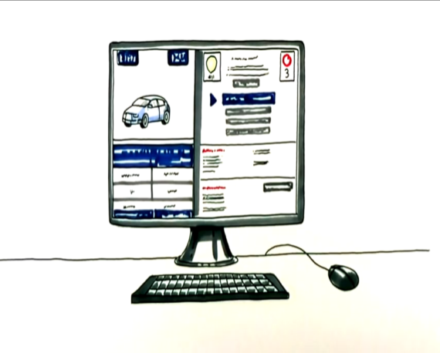

On the day of the auction, the sale begins on the basis of the price indicated in the advertisement. From this moment, the bidders interested in the good vehicles, will propose successively a price, each time superior to the preceding one.

The bid is withdrawn when no more bidder announces a new bid. It is the hammer of the auctioneer who closes the sale definitively.

# CHAPTER II: CONCEPTUAL STUDY

# Introduction

In this chapter we will present the management rules, data dictionary, entity / association model and the physical model.

## 1-MANAGEMENT RULES

* An administrator can add an administrator, offers, stock vehicles.
* An administrator can remove an administrator, offers, vehicles from the stock.
* a customer can identify himself, view the offers and participate in the auction.
* A visitor can see that home page and can also register.



## 2-DATA DICTIONARY

2.1 Administrator

|  |  |  |  |
| --- | --- | --- | --- |
| Administrator | Description (role) | Domain or type | constraints |
| Admin_code | Code for administrator | int | automatic |
| Name_admin | Name of administrator | character | mandatory |
| First_name_admin | First_name of administrator | character | mandatory |
| Email_admin | Email of administrator | character | mandatory |
| Password_admin | Password of administrator | character | mandatory |
| Phone_admin | Phone of administrator | character | mandatory |

2.2 Customer

|  |  |  |  |  |  |  |  |
| --- | --- | --- | --- | --- | --- | --- | --- |
| Customer | Description (role) | | | Domain or type | | | constraints |
| Customer _code | Code for Customer | | | int | | | automatic |
| Name_ Customer | Name of Customer | | | character | | | mandatory |
| First_name_Customer | First_name of Customer | | | character | | | mandatory |
| Email_ Customer | Email of Customer | | | character | | | mandatory |
| Password_ Customer | Password of Customer | | | character | | | mandatory |
| Phone_ Customer | Phone of Customer | | | character | | | mandatory |
| Country_ Customer | Country of Customer | character | | | mandatory | | |
| City_ Customer | City of Customer | character | | |  | | |
| Function_ Customer | Function of Customer | character | | | mandatory | | |
| Civility_ Customer | Civility of Customer | | character | | | mandatory | |

2.3 Vehicle Info

|  |  |  |  |  |  |
| --- | --- | --- | --- | --- | --- |
| Vehicle Info | Description (role) | | Domain or type | | constraints |
| Vehicle Info code | Code for Vehicle Info | | int | | automatic |
| Mark | Mark of Vehicle | | character | | mandatory |
| series | Series of Vehicle | | character | | mandatory |
| number of kid | Kid of Vehicle | | int | | mandatory |
| year manufacture | year manufacture of Vehicle | | Dated | | mandatory |
| Color | color of Vehicle | | character | | mandatory |
| Picture1 |  | text | | mandatory | |
| Picture2 |  | text | | mandatory | |
| Picture3 |  | text | | mandatory | |

2.4 Vehicle

|  |  |  |  |
| --- | --- | --- | --- |
| Vehicle | Description (role) | Domain or type | constraints |
| Vehicle _code | Code for Vehicle | int | automatic |
| Vehicle _type | type of Vehicle | character | mandatory |

2.5 Offer

|  |  |  |  |  |  |
| --- | --- | --- | --- | --- | --- |
| Offer | Description (role) | | Domain or type | | constraints |
| Offer _code | Code for Offer | | int | | automatic |
| Price_Offer | Price of Offer | | Double | | mandatory |
| Duration_Offer | Duration of Offer | | Hour | | mandatory |
| offer time min | time min of Offer | | Hour | | mandatory |
| Current price | Current price of offer | Double | |  | |

## ENTITY / ASSOCIATION MODEL

He provides a graphical description for representing such data models in the form of diagrams containing entities and associations. Such models are used in the upstream phases of computer system design.In the case of the Merise-based design of an information system built on a database, the conceptual data model is, at a later stage, transformed into a logical data model, such as the relational model; then this model is transformed into a physical model during the physical design phase. Sometimes these last two phases are called "physical design".

### 3.1 Conceptual model of the data

The conceptual data model (CDM) aims to formally write data which will be used by the information system. It is therefore a representation of the data, easily understandable, to describe the information system using entities.

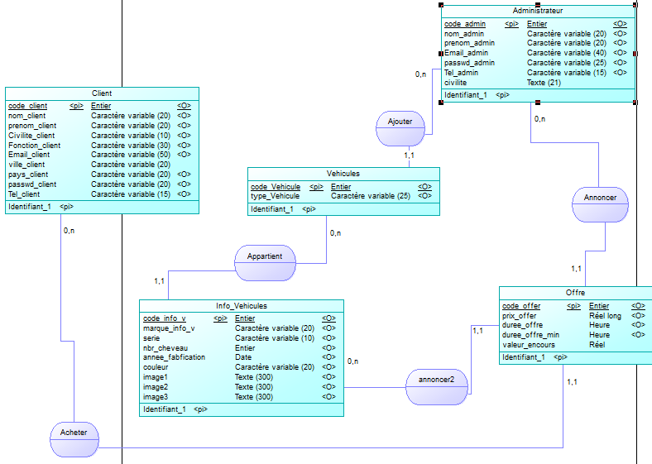

**Figure1 :** Conceptual model of the data

### 

### 3.2Physical model of the data

This step consists in implementing the model in the DBMS, that is, translating it into a data definition language.

The language generally used for this type of operation is SQL, and more specifically the SQL data definition language.

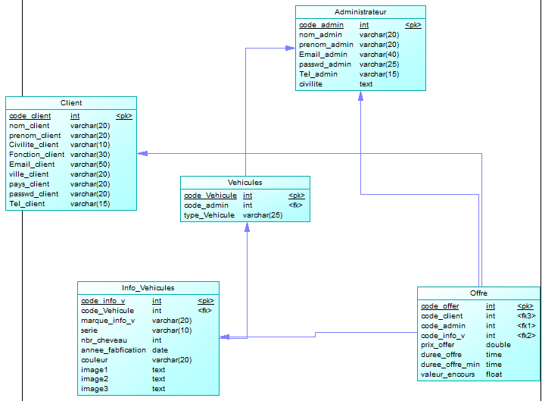

## Figure2 : Physical model of the data

# CHAPTER III: REALIZATION

# Introduction

In this chapter we will present the different technical choices and description of the interfaces.

## 1- TECHNICAL CHOICES

1.1Choice of language:

##### 1.1.1HTML language:

HTML is a computer language used on the internet. This language is used to create web pages. The acronym stands for HyperText MarkupLanguage. This meaning is aptly named since indeed this language makes it possible to create hypertext based on a markup **structure.**

##### 1.1.2 CSS language :

CSS is a computer language used on the internet to format HTML or XML files. Thus, style sheets, also called CSS files, include code that allows you to manage the design of a page in HTML.

##### 1.1.3 The PHP language :

##### This language is mainly used to produce a dynamic website. It is common for this language to be associated with a database, such as MySQL.Executed on the server side (the place where the site is hosted) there is no need for visitors to have particular software or plugins. Nevertheless, webmasters wishing to develop a site in PHP must ensure that the host takes into account this language.

This language was used for processing with our database (such as selection, insertion and modification ... etc.)

##### 1.1.4 The JavaScript language:

JavaScript is an object-oriented scripting language mainly used in HTML pages. In contrast to server languages ​​(which run on the site), JavaScript is executed on the user's computer by the browser itself. Thus, this language allows interaction with the user according to his actions (when moving the mouse over an element, resizing the page ...). The standardized version of JavaScript is ECMAScript.

Ajax:AJAX is the acronym for Asynchronous JavaScript And XML, otherwise JavaScript And XML Asynchronous.AJAX is neither a technology nor a programming language; AJAX is a Web programming concept based on several technologies like JavaScript and XML - hence the name AJAX. At present, XML tends to be abandoned in favor of JSON, which explains why some purists use the acronym AJAJ - whose pronunciation leaves something to be desired.

The goal of using Ajax in our project is to:

- Update a web page without reloading the page.

- Request data from a server - once the page is loaded.

- Receive data from a server - once the page loaded.

## 2-DESCRIPTION OF THE INTERFACES

**2.1 Visitor's area**



**Figure3 :** Home page

**2.2 Admin Area**

**Admin main page**

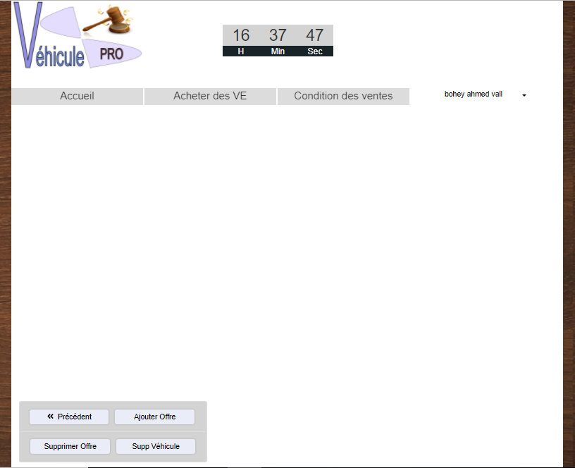

**Figure4:** Admin Area

This capture down bellow will explain how to add a car 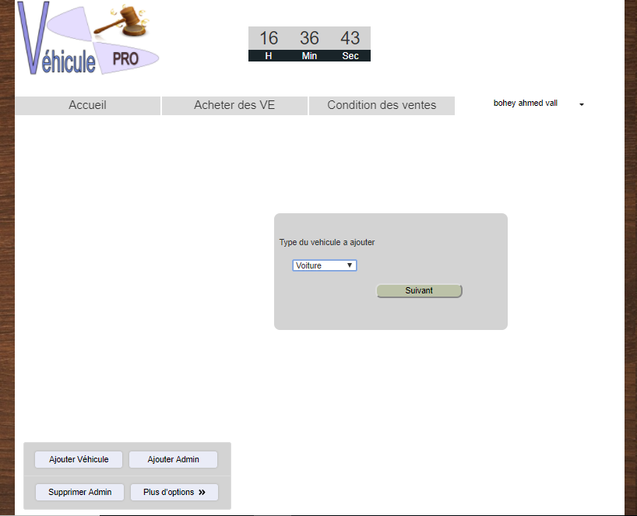

**Figure5:** page Admin

**2.3 Customer Area**

The homepage of a customer where there are all offers on vehicles.

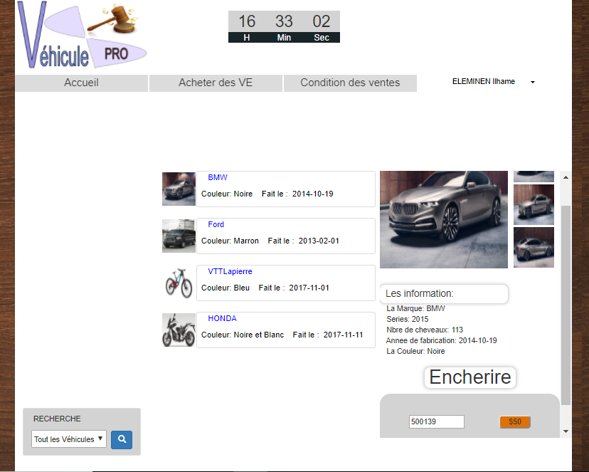

**Figure5 :** Customer Area

# General Conclusion

The interrnet has given a resurgence of life to the auction. For that we have chosen to realize an E-Commerce website allowing the auction to online auctions to encourage it too.

At the end of the realization of this work, we can say that this project has been very useful to us as it has allowed us to become familiar with e-commerce. technical plan only in relation.

During the realization phase of our website, we have elaborated a study of the existing in order to identify the insufficiencies of the web sites. This phase constituted the starting point for the analysis step and specification of the needs. Once our objectives were set, we proceeded to the realization phase during which we became familiar with Bootstrap.

The elaboration of this work allowed us, on the one hand, to deepen the knowledge and know-how acquired during the training, and on the other hand, to prepare our integration into professional life and to situate ourselves on the market. .

To conclude, our work can be subject to extension. Indeed, we plan to find the solution to set up an automatic auction system this mode of purchase is akin to a delegation of purchase up to an amount You determine the maximum amount for which you are buying the property. As long as this ceiling is not reached, the robot will automatically take care to keep you a better bidder.

# Webography

* <http://www.interencheres.com/>
* <https://images.search.yahoo.com/yhs/search;_ylt=A0geK9b5c7JaEFQABiYPxQt.;_ylu=X3oDMTByMjB0aG5zBGNvbG8DYmYxBHBvcwMxBHZ0aWQDBHNlYwNzYw--?p=vente+encheres&fr=yhs-iba-1&hspart=iba&hsimp=yhs-1>
* <https://encheres.petitesaffiches.fr/>
* <https://www.developpez.net/forums/d1130836/bases-donnees/langage-sql/insert-select-cle-etrangere/>
* <http://www.up2.fr/M1/td/foreignkey.html#etape2>
* <https://developer.mozilla.org/fr/docs/Web/HTML/Element/Input/hidden>
* <https://openclassrooms.com/forum/sujet/jquery-recuper-valeur-de-input>
* <https://www.xul.fr/ecmascript/settimeout.php>
* <http://www.commentcamarche.net/forum/affich-29145002-variable-jquery-a-php>
* <https://stackoverflow.com/questions/32842967/get-value-of-the-clicked-button>